

Sec: SR.IIT_*CO-SC(MODEL-B) Date: 18-09-22
Time: 3HRS Max. Marks: 300
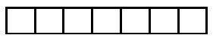
Name of the Student: ___________________ H.T. NO:

18-09-22_SR.STAR CO-SUPERCHAINA(MODEL-B)_JEE-MAIN_PTM-1_SYLLABUS
PHYSICS: Kinematics :Kinematics in one and two dimensions (Cartesian coordinates only), projectiles, Relative velocity.
NLM: Newton’s laws of motion; Inertial and uniformly accelerated frames of reference;
CHEMISTRY: Detection of elements: (N, S, halogens) and their estimation.
Structure: Hybridisation of carbon; σ and π-bonds; Shapes of simple organic molecules;
IUPAC nomenclature of organic molecules (hydrocarbons, including simple cyclic hydrocarbons and their mono-functional and bi-functional derivatives only);
Isomerism: Structural(Excluding Tautomerism) and geometrical isomerism; Stereoisomers and stereochemical relationship (enantiomers, diastereomers, meso) of compounds containing only up to two asymmetric centres (R,S and E,Z configurations excluded);

MATHEMATICS: Functions : Real Valued Functions Of A Real Variable, Into, Onto And One-To-One Functions, Absolute Value, Polynomial, Rational, Trigonometric, Exponential And Logarithmic Functions,
Even And Odd Functions, Sum, Difference, Product And Quotient Of Two Functions, Composite Functions, Inverse Of A Function
LIMITS

PHYSICS MAX.MARKS: 100
Section – I
(SINGLE CORRECT ANSWER TYPE)
This section contains 20 multiple choice questions. Each question has 4 options (1), (2), (3) and (4) for its answer, out of which ONLY ONE option can be correct.
Marking scheme: +4 for correct answer, 0 if not attempted and -1 if not correct.
1. A 90 m long train is moving towards north with a velocity of 10 m/s. A parrot is flying in the south direction parallel to train at 5 m/s. The time taken by the parrot in crossing the train in s is
A) 6 S B) 9 S C) 18 S D) None
2. A ball is thrown upward at an angle to the horizontal on a level ground. The minimum value of so that the instantaneous velocity makes an angle of 90⁰ with the initial velocity is
A)30⁰ B) 45⁰ C) 60⁰ D) 90⁰
3. Particles A and B are placed on a smooth horizontal plane. Their velocities and separation are given in figure. Horizontal separation decreases at the rate of
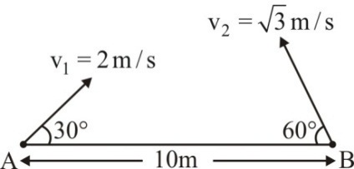
A) 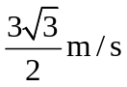 B)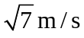 C) 1/20 m/s D) None of these
4. A boat which has a speed of 5km/hr in still water crosses a river of width 1km long along shortest possible path in 15 min. The velocity of river water in (km/hr) is
A) 1 B) 3 C) 4 D) 5
5. A wedge of angle of inclination is moving with constant speed v along horizontal direction. A particle is projected with vertical speed u relative to the wedge. The time of flight of the particle is
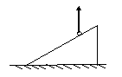
A) 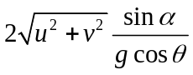 B) 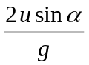 C) 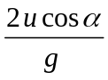 D) 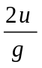
6. A point moves in the xyplane according to the law x = αt and y = αt – βt²where α and β are positive constants. The time after which the velocity makes an angle π /2 with the acceleration is
A) 1/ α B) α / 2β C) α / β D) 2/ α
7. A particle is moving in a plane and whose acceleration and velocity are given by 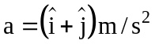 and 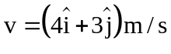 respectively. The tangential acceleration of the particle is
A) 0 B) 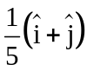 C) 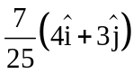 D) 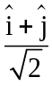
8. A ball is dropped from a height h, hits the ground and rises to height h/2. The variation of instantaneous velocity with time (take +Y direction directed downward) for the ball from the instant it is dropped to the instant it comes to instantaneous rest again is shown by

A) | 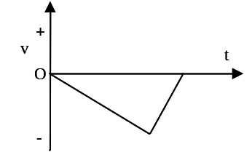 | B) | 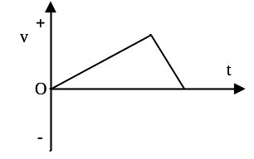
C) | 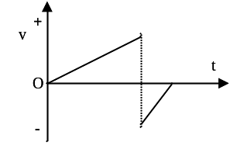 | D) | 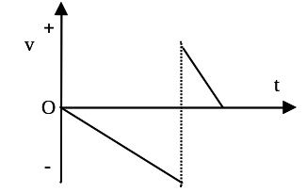

9. A boy throws a rock at an angle of 30º with horizontal from a mountain cliff of height 10 m. The rock falls on the ground below 4 seconds later. The maximum height attained by the rock above the ground is approximately is
A) 12.1 m B) 15.3 m C) 20.1 m D) 25.3 m
10. A knife of mass 1 kg is dropped from a height 4 m on a sandy floor. The knife retards uniformly in the sand covering a distance 1 m in it. The average resistance force applied by the sand on the knife is
A) 5g N B) 10g N C) 15g N D) 24g N
11. A lift moving down is slowing down at the rate of 2m/s².If g=10 m/s²then the normal reaction on a block of mass 1 kg lying on the floor of the liftis given by
A)8 N B) 12 N C) 10 N D) 6 N
12. Regarding a pseudo force the correct statement is
A) By using it Newton’s laws can be applied wrt inertial frames
B) acts on the observer
C) has no reaction force
D) It is equal to 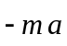, where 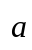 = acceleration of the object of mass m
13. Two masses A & B each of mass M are fixed together by a massless spring. force F acts on the mass B as shown. If the acceleration of A is a at the instant shown the acceleration of the mass B is
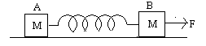
A) (F/M) -a B) a C) –a D) F/M
14. A person of mass 80kg jumps from a height of 1m and foolishly forgets to buckle his knees as he lands. His body decelerates over a distance of only 1cm. The total force on his legs during deceleration is (g is acceleration due to gravity)
A) 5050g N B) 4080g N C) 6060g N D) 8080g N
15. A particle of mass m is released on smooth inclined plane having inclination θ :
A)Vertical component of acceleration of particle is g
B)Vertical component of acceleration of particle is g cos²θ
C) Horizontal component of acceleration of particle is g sin θcosθ
D) Horizontal component of acceleration of particle is g sin²θ
16. Two blocks A and B of mass M and 2M respectively, are hanging from a ceiling by means of a light spring and a light string as shown. If the string between the blocks is suddenly cut, just after the cut, the accelerations of the blocks A and B will be respectively
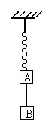
A) g upwards & g downwards B) 2g upwards & g downwards
C) g upwards & 2g downwards D) 2g upwards & 2g downwards
17. In an Atwood machine the masses are 2 and 4 kg. String is light and pulley is frictionless. Then the acceleration of the blocks is
A) g/6 B) g/4 C) g/3 D) g/2
18. A smooth rod is kept inside a trolley at an angle θ with the vertical as shown in the fig. The acceleration of the trolley so that the rod remains in equilibrium with respect to it is
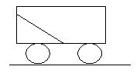
A) g tan θ B) g cos θ C) g sin θ D) g cot θ
19. A force of 60 N is acting at the origin of an oblique coordinate system in which x and y axes are inclined at 106⁰.If the force makes 53⁰ with x axis then the x component of the force is
A) 50 N B) 36 N C) 40 N D) 53 N

20. Equal force F (> mg) is applied to string in all the 3 cases as shown in the diagram.. Starting from rest, the point of application of force moves a distance of 2 m down in all cases. In which case the block has maximum displacement?
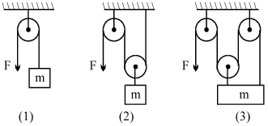
A) 1 B) 2 C) 3 D) equal in all 3 cases

SECTION-II
(Numerical Value Answer Type)
This section contains 10 questions. The answer to each question is a Numerical value. If the Answer in the decimals , Mark nearest Integer only. Have to Answer any 5 only out of 10 questions and question will be evaluated according to the following marking scheme:
Marking scheme: +4 for correct answer, -1 in all other cases.
21. An object is projected with a speed of 10 m/s at an angle 30⁰ wrt horizontal from origin on ground. If g = 10 m/s² then the height of the at the time of 1s after projection in m ,rounded off to the nearest integer, is
22. Particles 1, 2, 3 are projected simultaneously from a point at a height 840 m above the ground with same speeds 10 m/s along vertically downwards, horizontally and vertically upwards respectively. If t₁,t₂,t₃ are the flight times of 1,2 and 3respectively and all the particles are of different masses and acceleration due to gravity be 10 m/s² then the ratio of t₂ and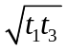is
23. If range of a projectile is equal to its maximum height then tan θ is equal to (θ is angle of projection)
24. A projectile, launched from ground, collides with a smooth vertical wall and returns to the ground. Coefficient of restitution between the wall and the projectile is 1/4. The time of flight is T₁. In the absence of the wall the time of flight will be T₂.Then the ratio of T₁ to T₂ is

25. The pulleys and strings shown in the figure are smooth and of negligible mass. For the system to remain in equilibrium, the angle in degrees should be
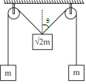
26. Three forces , 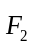 and 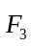 acting on a particle such that the particle is moving with constant velocity. Also, the angle between and is 80º, between and is 130º. Then the angle between and in degrees should be
27. For the given system, the angle of incline is 30º. All the surfaces are smooth. Pulleys and strings are massless. If M₁ = 2M₂ = 10 Kg, then the acceleration of M₁ is g/X. Then x is
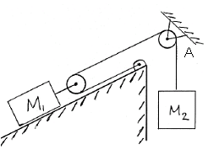
28. When the system is released from rest block of mass m₁ is at rest.If the masses of other two blocks are 6 and 3 kg then m₁ in kg is
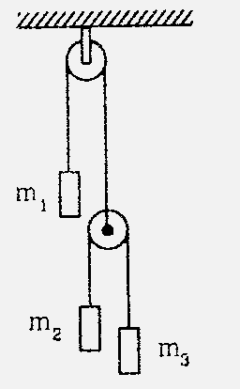
29. The support to which a simple pendulum is attached is accelerating at the rate of 2g.The ratio of maximum to minimum tensions in the string is
30. A monkey is moving along a rigid pole with a constant acceleration. If the breaking strength of the pole is twice the weight of the monkey, the maximum acceleration with which the monkey can move along the pole without breaking the pole is ng. Then n is
CHEMISTRY MAX.MARKS: 100
Section – I
(SINGLE CORRECT ANSWER TYPE)
This section contains 20 multiple choice questions. Each question has 4 options (1), (2), (3) and (4) for its answer, out of which ONLY ONE option can be correct.
Marking scheme: +4 for correct answer, 0 if not attempted and -1 if not correct.
31. Which of the following is not planer molecule ?
A) 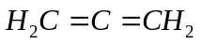 B) 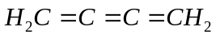
C) 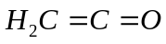 D) 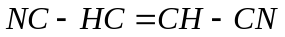
32. The most stable form of 2-nitroethanol is
A) 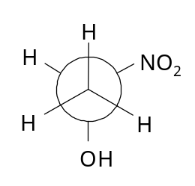B)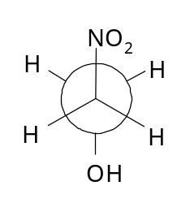C)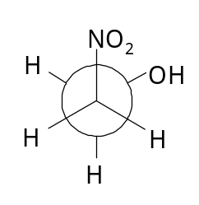 D)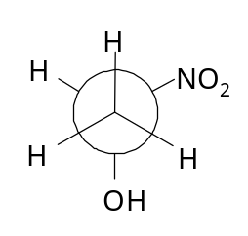
33. which of the following statements is nor true about RNA?
A)It controls the synthesis of protein
B) It has always double stranded helix structure
C) It usually does not replicate
D) It is present in the nucleus of the cell.
34. Which one of the following is the most stable conformer?
A) 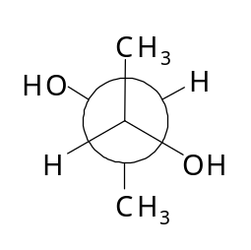B) 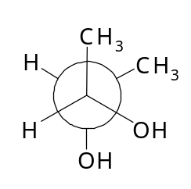C) 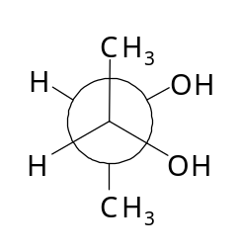 D) 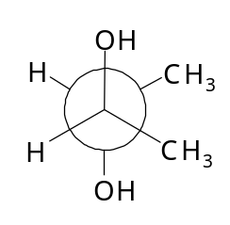
35. 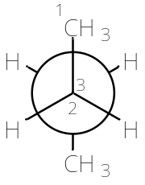
 is rotated anti-clockwise 120° about -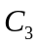 bond. The resulting conformer is
A) Partially eclipsed B) Eclipsed
C) Gauche D) Staggered
36. Which of the following compounds gives blood red coloration when is Lassaigne’s extract is treated with alkali and ferric chloride?
A) Phenyl hydrazine B) Diphenyl sulphide
C) Thiourea D) Benzamide
37. Which will form geometrical isomers?
A) 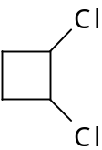 B) 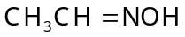 C) 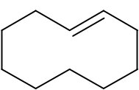 D) All of these
38. The geometrical isomerism is shown by
A) 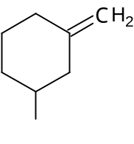 B) 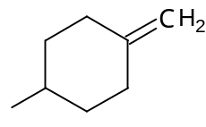 C) 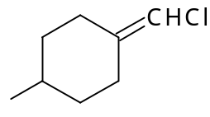 D) 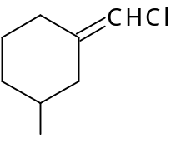
39. The most stable form of cyclohexane–1,2-diol is
A) 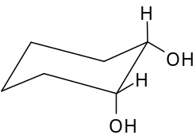 B)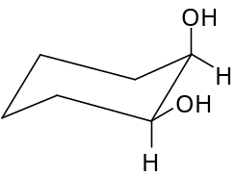 C)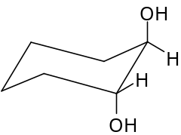 D)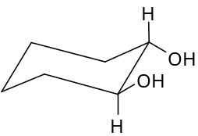
40. The absolute configuration of
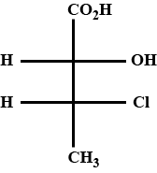
A) (2S,3S) B) (2R,3R) C) (2R,3S) D) (2S,3R)
41. The violet colour obtained during the test of sulphur by Lassagine’s test is
due to the formation of
A) 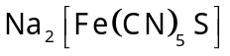 B) 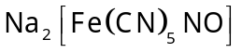
C) 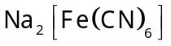 D) 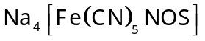
42. The correct stereochemical formula of Trans-3-chloro-1-phenylbut-1-ene is
A) 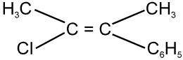 B) 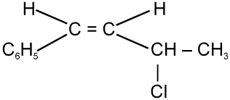
C) 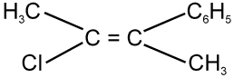 D)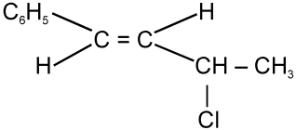
43. which of the following statements are correct ?
P) Gaucheform of 1,2 dichloroethane is more stable than anti form ( protic solvent)
Q) meso form of stilbene dichloride has high dipolemoment than its Active form
R) trans decalin is optically inactive and has two interconvertible conformations and more stable than cis decalin
S)cis decalin is optically active and has two interconvertible conformations and more stable than trans decalin
A) PQ B) PRS C) PQS D) PQRS
44. At what angle (Torsional angle) n-chloropropane is most stable
A) 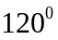 B) 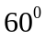 C) 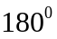 D) 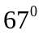
45. Which of the following compound exhibits geometrical isomerism?
A) styrene B) stilbene C) malic acid D) isobutene
46. Which of the following pairs of compounds are chain isomers?
A) n-Propyl alcohol and isopropyl alcohol
B) Isobutyl alcohol and t-butyl alcohol
C)sec-butyl alcohol and t-butyl alcohol
D) n-butyl alcohol and sec-butyl alcohol
47. Ethylene dichloride and ethylidene dichloride are
A) geometrical isomers B) chain isomers
C) position isomers D) not isomers

48. Select correct statements regarding following wedge dash projections
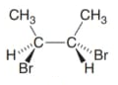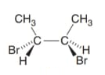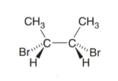
(P) (Q) (R)

A) P and Q are identical B) Q and R enantiomers
C) P and Q are diastereomers D) P and Q are enantiomers
49. The correct order/s for the given pair of isomers is
A) 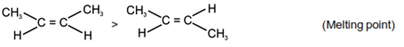
B) 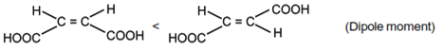
C) 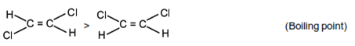
D) 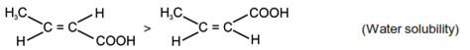
50. Which statement is wrong about symmetry ?
A) Plane of symmetry is an imaginary plane which bisects the molecules in two equal halves in such a way that each half of he molecule is the mirror image of the other half
B) Centre of symmetry is the point in molecule through which if the straight line is drawn from any part of the molecule and if then this line encounters identical groups at equal distances is opposite direction
C) A molecule which does not possess any element of symmetry is called asymmetric molecule
D) A molecule which does not possess any element of symmetry is calledsymmetric molecule

SECTION-II
(Numerical Value Answer Type)
This section contains 10 questions. The answer to each question is a Numerical value. If the Answer in the decimals , Mark nearest Integer only. Have to Answer any 5 only out of 10 questions and question will be evaluated according to the following marking scheme:
Marking scheme: +4 for correct answer, -1 in all other cases.
51. The total number of structural isomers having the molecular formula 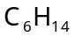 is
52. Number of stereoisomers possible for the following compound is
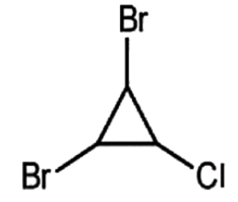
53. Total number of isomers, considering both structural and stereoisomers, of cyclic ethers
With the molecular formula 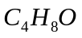 is____
54. How many of the following cases skew or gauche conformers are more stable
Than that of staggered foam
a) n – butane (c2-c3 rotation ) b) ethylene glycol
c) n-chlorobutane (c1-c2 rotation) d) 2,3 dimethyl butane
e)1,2- di-fluro ethane f) 2,2 3,3 tetrachlorobutane
55. Let X be the number of stereoisomers for pentane 2,3, 4 triol and Y be the number
of mesoforms then x+y is ?
56. How many of the following statements are correct regarding following conformers
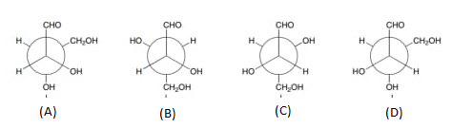
1) A andB are identical
2) C and Dare enantiomers
3) A and D have different melting points
4) A and C have same boiling points
5) AD and BD are diastereomeric pairs
6) BD are enantiomers
57. Taxol,an anticancer drug ,is shown below with out desh-wedge notation .How many stereocenters does Taxol have ?
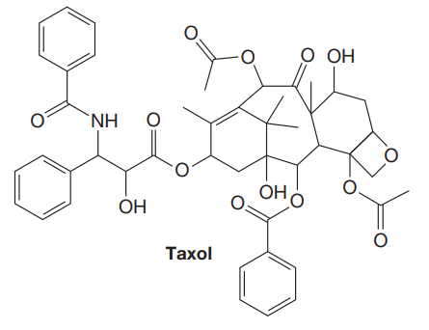
58. How many of the following molecules that are chiral ?
A) 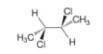 b) 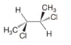c)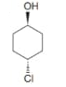 d) 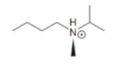
e)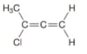 f)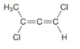 g)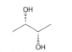 h)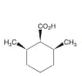
59. The number of stereoisomers possible for a compounds of the molecular formula 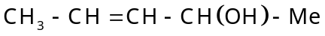 is
60. The number of structural aromatic isomers possible for 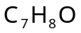 is

MATHEMATICS MAX.MARKS: 100
Section – I
(SINGLE CORRECT ANSWER TYPE)
This section contains 20 multiple choice questions. Each question has 4 options (1), (2), (3) and (4) for its answer, out of which ONLY ONE option can be correct.
Marking scheme: +4 for correct answer, 0 if not attempted and -1 if not correct.
61. If 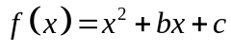and 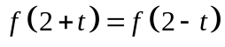 for all real numbers t, then which of the following is true?
A) 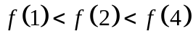 B) 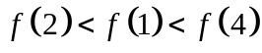
C) 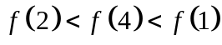 D) 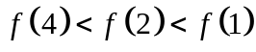
62. Let and 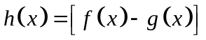 where [ ] denotes greatest integer function, then the range of 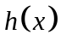is:
A) 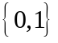 B) 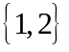 C) 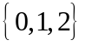 D) 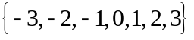
63. Let 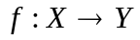be defined as 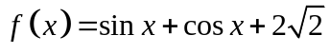. If f is invertible, then 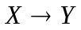, is:
A) 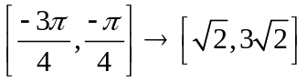 B) 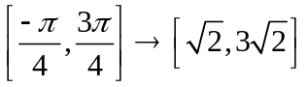
C) 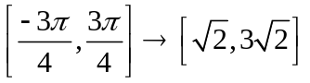 D) 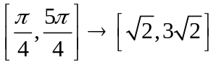
64. If the range of function 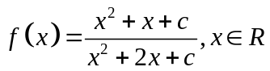is 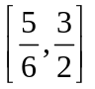, then c is equal to:
A) –4 B) 3 C) 4 D) 5
65. The sum of all possible solution(s) of the equation 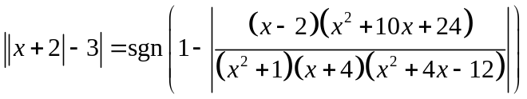is:
(Note: sgn (y) denotes the signum function of y)
A) 0 B) –8 C) –10 D) Not applicable

66. Let 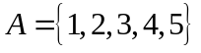and 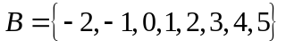then which of the following is INCORRECT?
A) Number of increasing functions from A to B = 56
B) Number of non–decreasing functions from A to B = 792
C) Number of onto–functions from A to B = 1052
D) Number of onto–functions from A to A such that 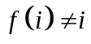for all , is 44
67. ABC is an isosceles triangle inscribed in a circle of radius r. If AB = AC and h is the altitude from A to BC and P be the perimeter of ABC then 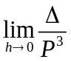 equals (where is the area of the triangle):
A) 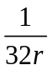 B) 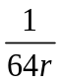 C) 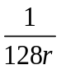 D) None of these.
68. If 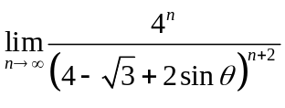exists and is equal to 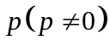where 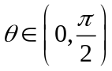, then the value of 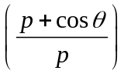is equal to:
A) 7 B) 8 C) 9 D) 10
69. The range of the function 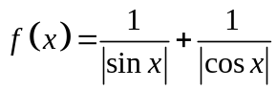is:
A) 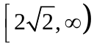 B) 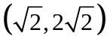 C) 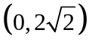 D) 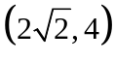
70. 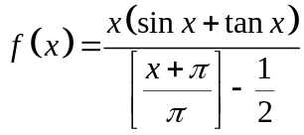, when 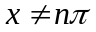. Where, [ ] denotes greatest integer function is ...........
A) Even function B) Odd function
C) Neither even nor odd D) Periodic function

71. Let 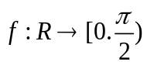 be defined by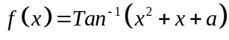. Then the set of values of a for which f is onto is
A) 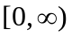 B) 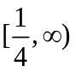 C) 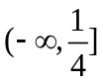 D) 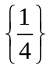
72. If 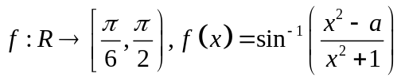is a onto function, then set of values of ‘a’ is:
A) 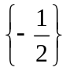 B) 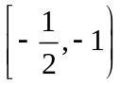 C) 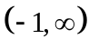 D) None of these.
73. 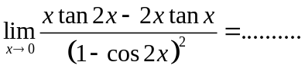
A) 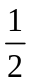 B) 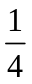 C) 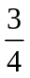 D) 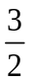
74. The domain of the function 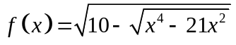 is
A) 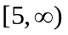 B) 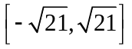
C) 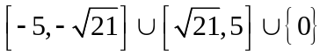 D) 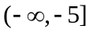
75. If 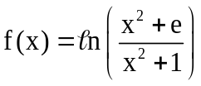, then range of f(x) is
A) (0, 1) B) (0, 1] C) [0, 1) D) {0, 1}
76. If 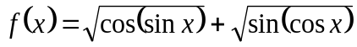, then the range of f(x) is
A) 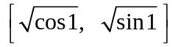 B) 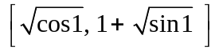
C)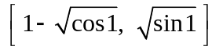 D) 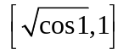
77. The domain of the function
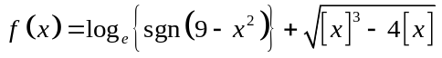where [.] = G.I.F
A) 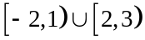 B) 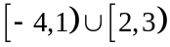 C) 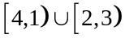 D) 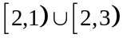
78. Let 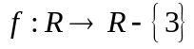 be a function such that for some 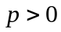, 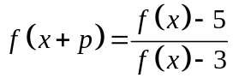 for all 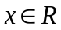. Then, period of  is
A) 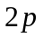 B) 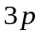 C) 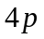 D) 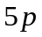
79. Let 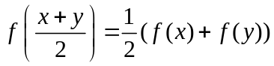 for real x and y. If 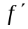(0) exists and equals to -1
and f(0)=1 then the value of f(2) is
A) 1 B) -1 C) D) 2
80. 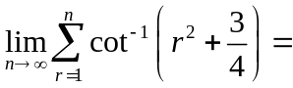
A) 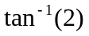 B) 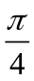 C) 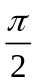 D) 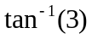

SECTION-II
(Numerical Value Answer Type)
This section contains 10 questions. The answer to each question is a Numerical value. If the Answer in the decimals , Mark nearest Integer only. Have to Answer any 5 only out of 10 questions and question will be evaluated according to the following marking scheme:
Marking scheme: +4 for correct answer, -1 in all other cases.
81. If 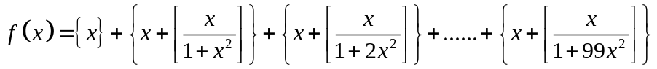 then value of 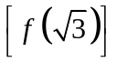is:
[Note: [k] and {k} denote greatest integer and fractional part functions of k respectively]
82. If 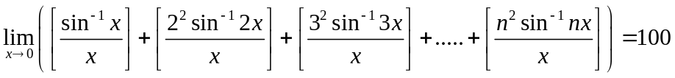, then the value of n, is:
[Note: [k] denotes the greatest integer less than or equal to k.]
83. If f is an even function then the number of real values of x satisfying the equation 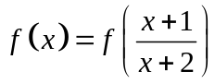.
84. The number of solutions of, 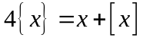is......
[ Note: [x]=step function;{x} = fractional part function]
85. 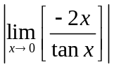, where [.] denotes greatest integer function is:
86. If a,b,c,d,e are positive real numbers, such that 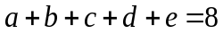and 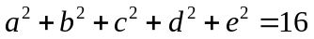, then maximum value of ‘e’ is..........
87. If g(x) is a polynomial satisfying g(x) g(y) = g(x) + g(y) + g(xy) –2 for all real x and y and g(2) = 5, then g(3) is equal to
88. A function f satisfies the equation 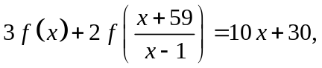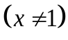
then the value of 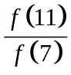 is
89. Let f be a function such that 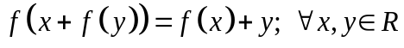 then 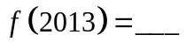
90. If  is a polynomial of degree 4 with leading coefficient one satisfying 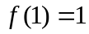, 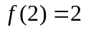, 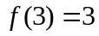 then 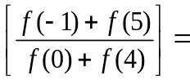 ( 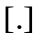 denotes GIF)

